Git link :

https://github.com/Dhyey1811/Assignment-2-Database.git

Azure Database :

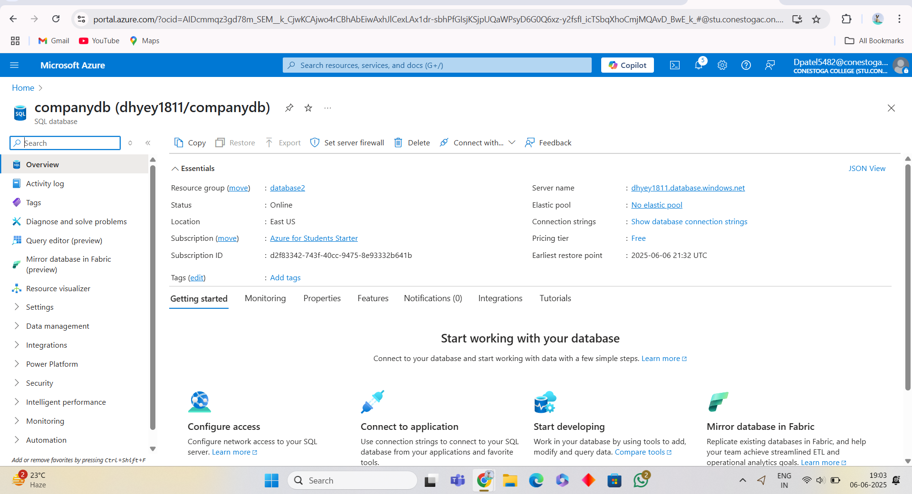

Git workflows :

